**DC pumps (12V)**

**DC** powered **pumps** use **direct current** from motor, battery, or solar power to move fluid in a variety of ways. Motorized **pumps** typically operate on 6, 12, 24, or 32 volts of **DC** power.

**[Brushless dc water pump](http://www.dcbrushlesspump.com/" \t "_blank)** with a brushless DC motor and coupled with the impeller in its rotor in the housing structure.Due to the water around the rotor there is no Brush friction,therefore the spark is not generated.brushless water pump is a typical electromechanical Integration products.  
Difference between **[Brushless water pump](http://www.dcbrushlesspump.com/e_products/?big_id=1" \t "_blank)** and traditional brushed water pump:  
Due to the motor shaft and the rotor impeller directly connected and shaft seals, therefore the shaft and gasket works in friction status.so the brushed water pump life is very short. and the industry applictions is also limited.  
**Brushless dc water pumps** with magnetic conversion instead of the traditional structure pump.the motor and the rotor impeller is completely isolated by waterproof chamber so the sealing problems is completely solved. due to the rotating parts with the perfect combination of zirconium oxide and graphite ,the mechanical friction is minimized ,along with the longer life and low noise.  
With Brushless motor,the function of the brushless water pump is aso perfect: governor function, FG signal output, overvoltage protection, overcurrent protection, anti-slip protection, over temperature protection, low-voltage solar start  
welcome to vist our website to know more about **[brushless dc pump.](http://www.dcbrushlesspump.com/" \t "_blank)**

The applicatons of our [**Brushless Dc Pump**](http://www.dcbrushlesspump.com/e_products/?big_id=1)and **[BLDC Pump](http://www.dcbrushlesspump.com/e_products/?big_id=2" \t "_blank)** are wide. They are widely used in home appliances,medical equipments,  cars, office equipments, and environmental protection equipments ,power equipments such as air cleaner,coffee machines, electric tea pot, electric vehicles, cars, solar water circulation system, solar water heater, fountain, aquarium, trucks engines ,water circulating and coolant of air-condition, computer, water cooling of electrical appliances, handicrafts,etc.

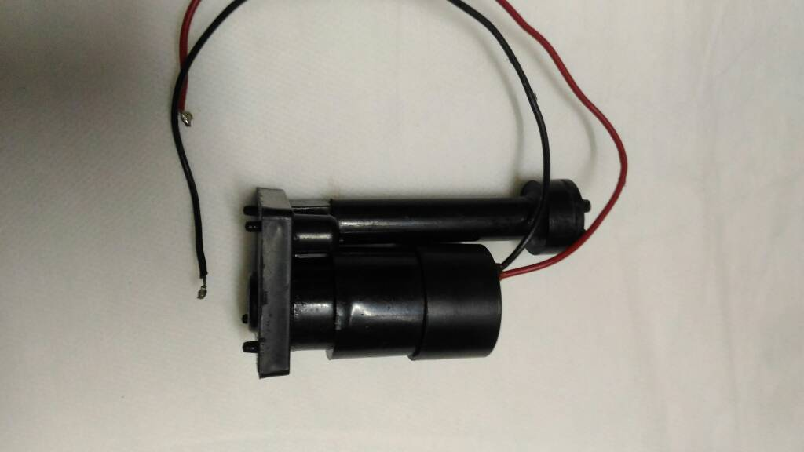

Features:

1.Super long working lifespan (more than 30,000 hours), maintenance-free

2.Brushless motor, no electric spark, safer  
  
3.Small size, low consumption, low noise(less than 40dB)  
  
4.Submersible installation and entirely waterproof  
  
5.High-performance ceramic sleeve and ceramic shaft (optional)

7.Can be applied in many fields, such as computer cooling system, garden fountain, aquarium, car cooling system, humidifier, air conditioner, and many other cooling and circulation systems

Advantages of our DC pump

Ø

1.Brushless, permanent magnetic rotor, maintenance-free, long life.

2. Small size, high efficiency, low consumption, low noise.

3. Ceramic sleeve and ceramic shaft 【optional】.

4.Stator and circuit board sealed by epoxy resin, completely water proof.

5.Parameter adjustable, 12v pump’s head can be 2m to 5m.

6.Can be customized.